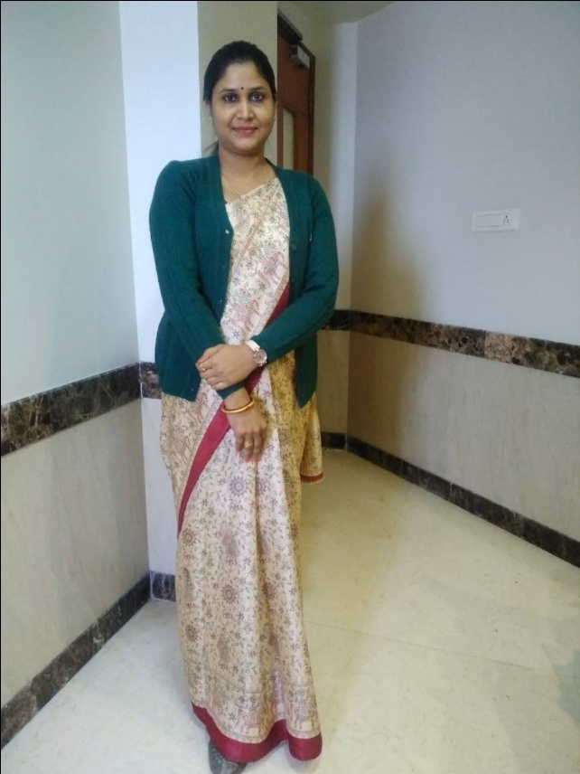 | Dr. Lokeshwari  (M.A., NET, SLET, Ph.D.)  Affiliation:  Assistant Professor, Department of Sociology, University of Rajasthan, Jaipur  Email ID: lokeshwari.uniraj@gmail.com  Contact Number:  9414952665

Dr. Lokeshwari is an Assistant Professor in the Department of Sociology at University of Rajasthan, Jaipur since 2014. Her current basement is University Maharani’s college, Jaipur. Previously she had been in Government College Education from the year 2008 to 2014 in Rajasthan. She has 14 years of teaching experience and during this period she has published 09 research articles, attended 33 national as well as international conferences and seminars. Her major areas of interests are gender studies, tribal and dalit studies, culture, family and marriage issues. Topic of her Ph.D. research was ‘Problems and Challenges of Working Women’.
She has worked on a research project under UGC DRS SAP III (2019). She has been convener and co-convener in many departmental and conference committees. She is a Life Member of professional bodies like Rajasthan Sociological Association (LM-420), Indian Society of Gandhian Studies (LM-240), North West Indian Sociological Association (NWISA) (LM-572) and Indian Sociological Association. She has been elected as Member Executive in 2021 election of Rajasthan Sociological Association (RSA).

