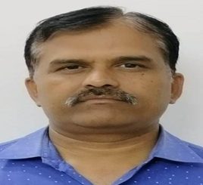 | M.L JANWA, Principal, Aspire Degree College, Bemla ( Kurabad )  MLSU, Udaipur
M.L JANWA is Principal of Aspire Degree College, Bemla ( Kurabad ) He has almost 19 years of teaching experience. His research interest includes Rural , tribal and Panchayati Raj. He has published several articles in various books and journals on the related themes. He has worked as research associates, Research Supervisors in so many projects conduct by CSDS New Delhi, IIHMR Jaipur, ISI New Delhi, IIPS Mumbai, CSCR Udaipur.
He has also done his Post Doctorate Research. At present he is elected member executive for this association and treasurer of Samajshastra Hindi Kariya samati Udaipur.. He has delivered lecturer as a resource person at various platforms. Whole Life member of Indian sociological Association New Delhi, Rajasthan sociological association Jaipur, Samajshastra Hindi Kariya samati Udaipur, He has paper presented in various conference.

