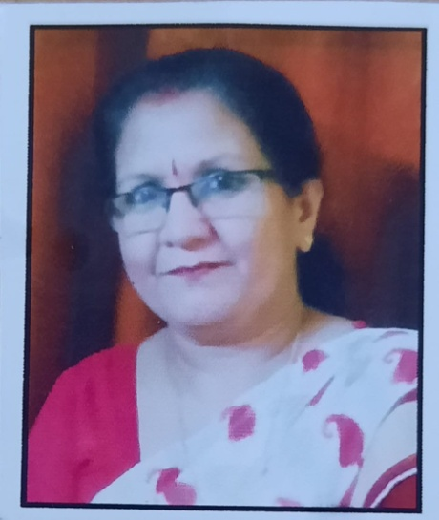 **Dr. Charulata Tiwari**

**Affiliation**: Associate Professor

Deptt. Of Sociology Govt. Girls College

Jhalawar Kota University – Kota

**Email:** [**Charutiwari11@gmail.com**](mailto:Charutiwari11@gmail.com)

**Mob. No. :** 9414569438 ,8290190456

**Dr. Charulata Tiwari** is Currently Working as Associate Professor and Head Department of Sociology Govt. Girls College Jhalawar Affiliated to Kota University - Kota Rajasthan. She received Her Bechelor Degree (1988) Post Graduation (1990) **Ph.D in Sociology (1994)** From Devi Ahilya University Indore (M.P.). She was an Experience of Teaching for more than 23 years. She has Got Published 12 research paper in reputed Journals/edited books, authored 03 books and her areas of specialization are women studies, Female Labour. She is Life Member of several acadmice and Professional Bodies. **Rajasthan Sociological Association (RSA)**, **Social Science and Humanities Association (SSHA),** **North West Indian Sociological Association (NWISA)** She has been **Elected as the member executive (RSA).** She was **co-opted member Kota University - Kota**.

She has been **Awarded By District Administration Jhalawar** for her Contribution in Co-educational activities. Akashar Varta International Research Journal Ujjain **‘’AWAGAT AWARD– 2021’’** and District Library Jhalawar. Under her guidance students participated in competitions at district and state level and got secured distinct position. She is associated with many socio-cultural institution, appointed as judge at the district and divisional level. Her **social educational talks** are spread through **Akashvani Jhalawar**.