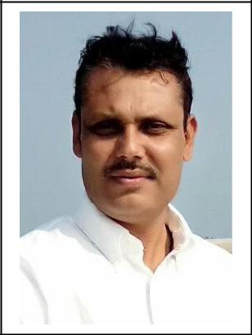**Dr. Paresh Dwivedi**

‘Adhayatma’ 30-Roop Nagar

Hiran Magri, Sec. No. – 3,

Udaipur, Rajasthan

Mobile – +91-94147-37462

E-mail : [pareshdwivedi@yahoo.com,](mailto:pareshdwivedi@yahoo.com,) [drpareshdwivedi1969@gmail.com](mailto:drpareshdwivedi1969@gmail.com)

**Qualification**

M.A. (Sociology), NET (UGC) and Ph.D.

**Positions Held**

Head, Dept. of Sociology, B.N. University, Udaipur

|  |  |  |
| --- | --- | --- |
| **Teaching Experience** |  |  |
| U.G. Classes | - | 21 years |
| P.G. Classes | - | 18 years |
| **Field Experience with NGO** | **-** | 09 years |
| **Ph.D. Guided** | - | 04 Nos. |
| **Dissertation** | - | 18 Nos. |
| **Total No. of Publication** |  |  |
| Paper / Article | - | 17 Nos. |
| **Book Published** | - | 1 Nos. |
| **Paper Presentation in Conferences and Seminars** | | |
| National & Intrnational | - | 50 Nos. |
| Workshop / Orientation / Refresher | - | 8 Nos. |
| **Awards :** | **-** | 4 Nos. |
| **Professional Membership** | **-** | 9 Nos. |
| **Area of Interst** | **-** | Crime, Rural Development, Health, Yoga and |
|  |  | Spirituality, Women Empowerment and Ageing |