**Dr. ShailendraGehlot**

[**gehlot_shail@yahoo.com**](mailto:gehlot_shail@yahoo.com)

**Contact No: +91-9828229912**

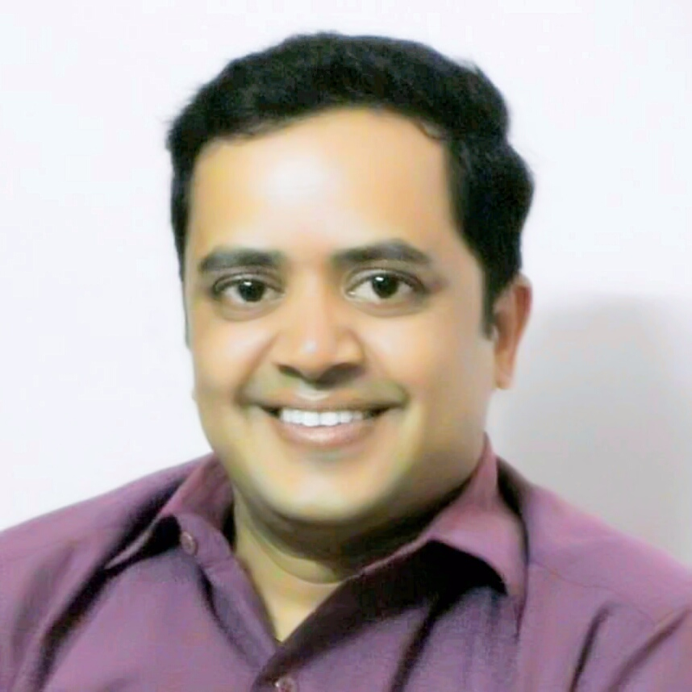

**Objective:**

**To achieve high career growth through a continuous learning process and keep myself dynamic and visionary with the changing scenario of the world.**

**Work Experience:**

* **Working As Assistant professor in Sociology At Department Of College Education Rajasthan Since 2008**
* **Currently working as Assistant professor in Sociology At Govt. College Jodhpur (Rajasthan)**

**Personal Details:**

* **Father’s Name : Mr. Prithvi Singh Gehlot**
* **Date of birth : 15th May,1977**
* **Nationality : Indian**
* **Permanent Address : Jeevan das KaKuan, Inside Nagori Gate, Jodhpur**

**Academic Qualifications:**

* **LL.B. 2009 (JNVU Jodhpur )**
* **Ph.D 2006 (JNVU Jodhpur )**
* **SLET 2001 (RPSC, Ajmer)**
* **M.A. (Sociology) 2000 (JNVU Jodhpur )**
* **B.Sc 1998 (JNVU Jodhpur)**

**Publication Details :**

* **Paper Published in International Journal.**

Paper published in international journal:

1 GEOBIOS(ISSN 0251-1223) Vol.41, No.2-3

May-August.2014.

Title-Expansion of transmission window(TW) is a direct threat to malaria. Page no. 68-71

2.ABEER(ISSN NO. 2249-3409) OCT-DEC. 2016

Title: Educational development and social life of Scheduled castes. Page no. 22-25

3.Research Analysis(ISSN NO. 2278-375X)

Vol. VI, No.2, July-December 2016.

Title: Health issues of Elderly: Problems and Solution. Page no. 25-31

4. Remarking (P ISSN No.2394-0344

E ISSN No.2455-0817)VOL- IV* ISSUE-I*April- 2019 Part:-2

Title: Women Empowerment in India: Strategy and Execution. Page no. E213-221.

5. Periodic Research (P ISSN No.2232-0045 E ISSN No.2349-9435) VOL.-7, ISSUE-4 (Part-1) May-2019

Title: Impact of social networking sites on college students. Page no. E-227-234

6 International Journal of Psychosocial Rehabilitation, Vol. 24, Issue 04, April 2020 ISSN: 1475-7192

Title: Domestic violence against women: Reason and Remedy. Page no. 10363-10373 {Scopus indexed}

7. Dogo Rangsang Research Journal

ISSN : 2347-7180 UGC Care Group I Journal Vol-10 Issue-08 No. 09 August 2020

Title: The Unseen Face of Mankind: Earning Money on Dead Bodies of COVID19 Victims by Private Agencies. Page no. 85-93

Chapter contribution in edited books

1 Book name: Futuristic society after COVID-19 in India and Abroad. ISBN NO. 978-1-63606-221-1 by Express publishing. August 2020.

Editors~ Meenakshi Meena, Shailendra Gehlot, Anupama Dixit, Hitesh Goyal.

Chapter no. 11- Impact of coronavirus (COVID-19) on Indian economy. Page no. 189-198

1 Book name: वैश्विक संदर्भ में कोविड-19, चुनौतियां एवं संभावनाएं. ISBN NO. 978-1-63606-079-8 by Express publishing. August 2020.

Editor~ Meenakshi meena

Chapter no. 3 - भारत में कोविड-19: चुनौतियां एवं समाधान. Page no. 27-38

Edited Books

1 COVID19: Challenges and possibilities.

A multi dimensional approach.

August 2020. International book

Published By LAP LAMBERT ACADEMIC PUBLISHING. Mauritius

ISBN NO. 978-620-2-67997-8

2 COVID19 Impact on human life: Indian and global scenario.

August 2020.

Published By Xpress publishing.

ISBN NO. 978-1-64951-584-1

3 Futuristic Society After COVID-19 in India and Abroad.

August 2020.

Published By Xpress publishing.

ISBN NO. 978-1-63606-221-1

**Award and Achiements:**

1. **Best Poster Presentation Award at National Conference on Environmental Challenges Human Health and Society at UOR Jaipur Sep, 2016.**
2. **Best Young Faculty Award by Novel Research Academy Puducherry, India Nov, 2019.**
3. **Organized international E- Conference of SSHA on 27-28 June 2020**

**Declaration:**

**I hereby declare that the information furnished above is true to the best of my knowledge.**

**Place: Jodhpur Dr. ShailendraGehlot**