**Dr. Lalit Kumawat**

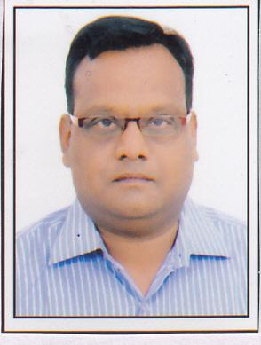

**Principal at MAG PG College**

**Fateh Nagar, Udaipur**

**9414343805**

**veethi.k@gmail.com**

**Teaching Experience:** 16 Years

**Area of Interest**

* Election Study
* Field Research
* Changing Pattern in Indian Society
* Peoples Participation in Society & State

**Research Experience**

* Worked as a Field Investigator, Field Supervisor, Research Associate in More than 25 projects conducted by various national and international agencies.

**Publication**

* 1 Book on Women Participation in Panchaytiraj
* More than 12 Articles and research papers on various issues including social aspects like Human Rights, Local Governance, Panchaytiraj etc.